**A report**

**on work carried out for improving on the project**

**“Redesigning Control Interface of the Induction Stove suiting to Indian Users”**

from 29-12-2011 to 20-01-2012

Submitted by-

N.KARTIK

M.C.A final year

Nitte Meenakshi Institute of Technology, Bangalore

Submitted to-

Pradeep Yammiyavar, M.Des, Ph.D, FDRS

Professor

Design Research &

Usability Engineering Department of Design

Indian Institute of Technology, Guwahati, 781 039 India

**Problem statement**:

To improve upon control interface of induction stove suiting to Indian users

**Introduction:**

An Induction stove uses induction heating to directly heat a cooking vessel whereas a traditional cooking stove transfers heat from electrical coils or burning gas. To be used on an induction cook top, a cooking vessel must be made of a ferromagnetic metal. Otherwise, the vessel has to be placed on an interface disk which enables non-induction cookware to be used on induction surface.

The control interface in the exiting standard Induction stove is prepared keeping western standards in mind. This is unsuitable with Indian Cooking style. So modification of existing control interface is required.

In this regard, considering Indian standards, a flame control knob is introduced. Some of the other controls have been either renamed or removed.

**Implementation:**

**Design Tool**: Microsoft visual studio 2005

**Programming Language**: c#

There are two forms present in the project. In form1 all the controls are placed on the right hand side which should be placed in the grid once the entire control placed user will press freeze button.

When freeze button is enabled form2 with less opacity will appear in front of form1 so that modification cannot be performed on form1. The evaluation process is started as soon as freeze button is pressed. If a control is not placed in desired position of the control panel a message will be generated saying “It was not placed in proper position” on the other hand if control is placed in proper position user will be give message, explaining why the control should be placed in that position.

Before placing the controls-

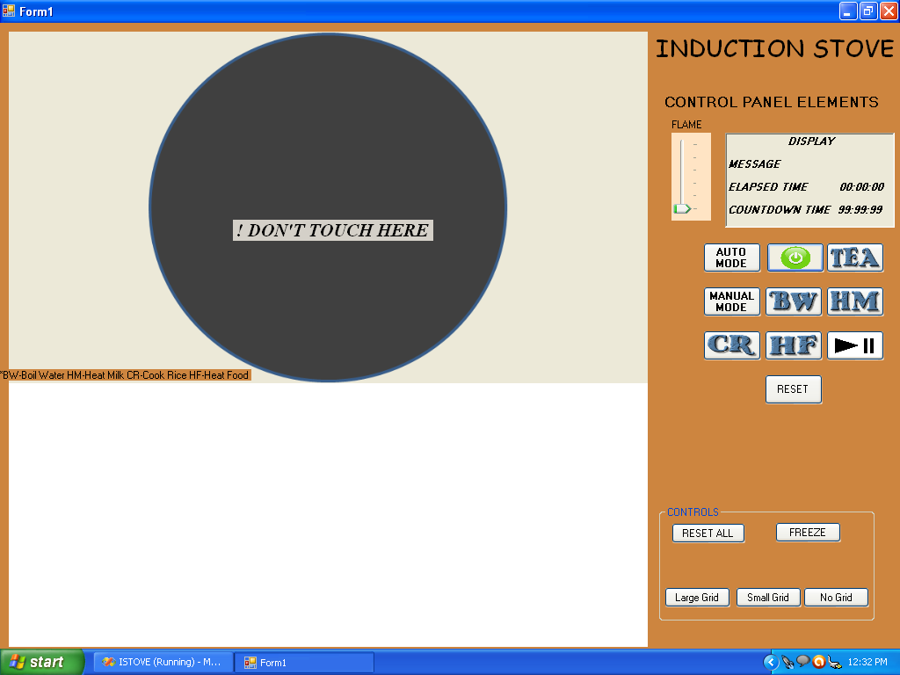

After placing the control in grid-

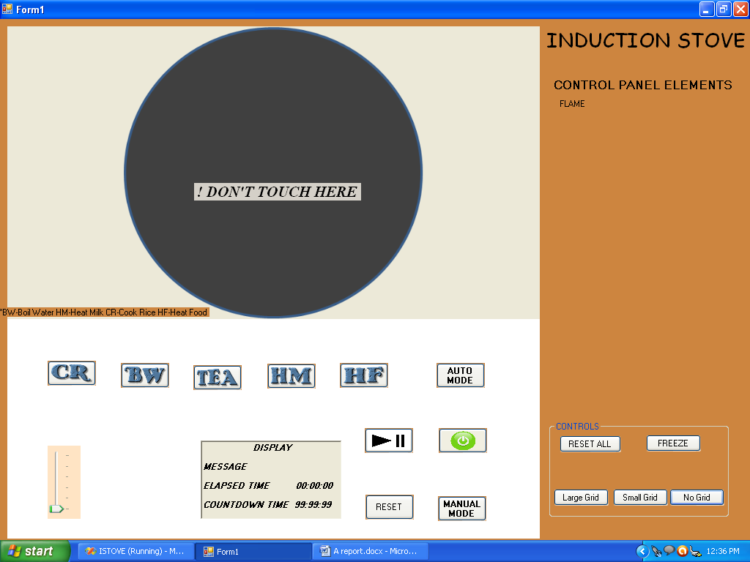

If controls are not placed in proper postion-

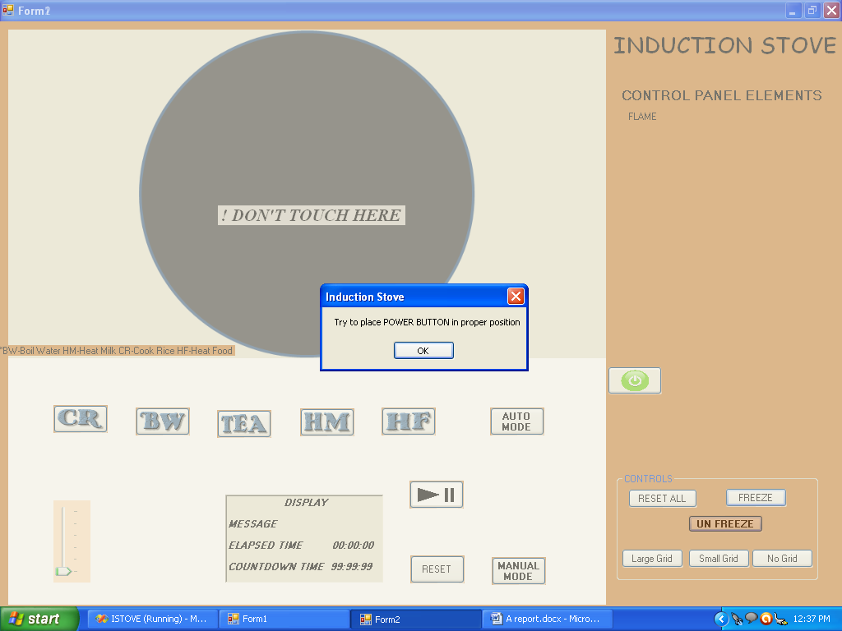

Controls Used-

|  |  |  |
| --- | --- | --- |
| Control | Name | Description |
| Trackbar | Flame | Used to control the heat level of induction stove |
| richTextbox | Display | Used as display unit for countdown, elapsed time and messages |
| Buttons  (for the user to place in grid) | Auto | Automatic operation will be enabled |
| Manual | Manual operation will be enabled |
| Power | To switch on/off the induction stove |
| Tea | To set Induction stove for Tea mode |
| BW | To set Induction stove for Boil Water mode |
| HM | To set Induction stove for Heat Milk mode |
| CR | To set Induction stove for Cook Rice mode |
| HF | To set Induction stove for Heat Food mode |
| Start/Pause | To Start/Pause the Induction Stove |
| Reset | To Reset the Induction Stove |
| Buttons  (for control) | Reset All | To set the controls in original position and to start again |
| Freeze | Once the button is pressed evaluation process of whether the control is placed in proper position or not is checked |
| Large Grid | Shows grid in the panel |
| Small Grid | Shows grid in the panel |
| No grid | This will be default panel will be plain |

**Acknowledgements**:

1. Prof Pradeep Yammiyavar, IIT Guwahati, for his encouragement and motivation
2. Mr Rhiddhiman Patowary, for his help and guidance
3. Mr Bikash Agarwal , for the original work